What happens to polluted water
within the water cycle?

Name: _________________________________________________ Date: __________________

Answer the questions below based on what you learned from the water cycle experiment.

- What is the water cycle?
The water cycle is the continuous process by which water moves between the Earth's surface and the atmosphere. It involves several key processes including evaporation, condensation and precipitation.
- Fill in the gaps with the words of key stages:
- evaporation
- condensation
- precipitation
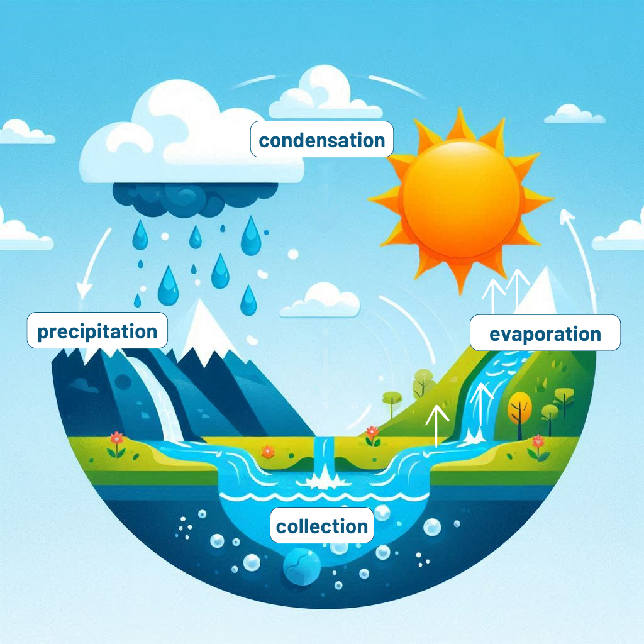
Or:
- Draw a simple picture that shows the water cycle.
Label the key stages:
- evaporation
- condensation
- precipitation

- Describe in your own words what happens at each key stage.
Evaporation:
This is the process by which water changes from a liquid to a vapour or gas state. Heat from the sun causes water to evaporate from oceans, lakes, rivers, and other bodies of water, as well as from soil and vegetation.
Condensation:
As water vapour rises into the atmosphere, it cools and condenses into tiny water droplets, forming clouds. This process occurs when warm, moist air rises and meets cooler air at higher altitudes.
Precipitation:
When the water droplets in clouds grow large and heavy enough, they fall back to the Earth's surface as precipitation. This can take the form of rain, snow, sleet, or hail, depending on atmospheric conditions.
- What happens to the water in the container when it is placed near a sunny window?
When you place the setup near a sunny window, the sun's energy causes the water to heat up. As a result, water molecules at the surface gain enough energy to change from a liquid state to a gas (water vapour).
- Why do we use red paint or food colouring in the water for this experiment?
We use red paint or food colouring in the water for this experiment to simulate the water pollution.
- What role does the plastic film play in the experiment?
The plastic film simulates the Earth's atmosphere. It helps to restrict the escape of evaporated water.
- What role does the stone play in the experiment?
The stone placed on top of the bottle causes the plastic film to bend and the condensed water slides over it to the lowest point. When enough water droplets have formed and their combined weight overcomes the resistance of the plastic film, they "fall" or "rain" into the cup below. This is precipitation, and it mimics the process of rain or other forms of water falling from the sky in the natural water cycle.
- At the end of the experiment, is the water collected in the cup clear or red? Why?
Inside the glass the water is clear because we have collected the purified water and our pollutant was left behind.
- Write a short text and explain:
- Why is it important to understand the water cycle and how nature filters water?
- What can you do to help conserve water and protect the environment?
Understanding the water cycle is important because it helps us know how water moves around our planet.
The water cycle is like a big recycling system for water. When it rains, the water goes into the ground and gets cleaned up by the soil and rocks. Plants also help by soaking up water and releasing it back into the air through their leaves.
To help save water and protect nature, we can do small things like turning off the tap when we brush our teeth, taking shorter showers, and not wasting water when we play outside.
We can also help keep our environment clean by not littering, planting trees, and picking up trash around our neighbourhoods. Every little bit helps to take care of our planet!

