What happens to polluted water
within the water cycle?

Name: _________________________________________________ Date: __________________

Answer the questions below based on what you learned from the water cycle experiment.

- What is the water cycle?
_____________________________________________________________________________
_____________________________________________________________________________
_____________________________________________________________________________
- Fill in the gaps with the words of key stages:
- evaporation
- condensation
- precipitation
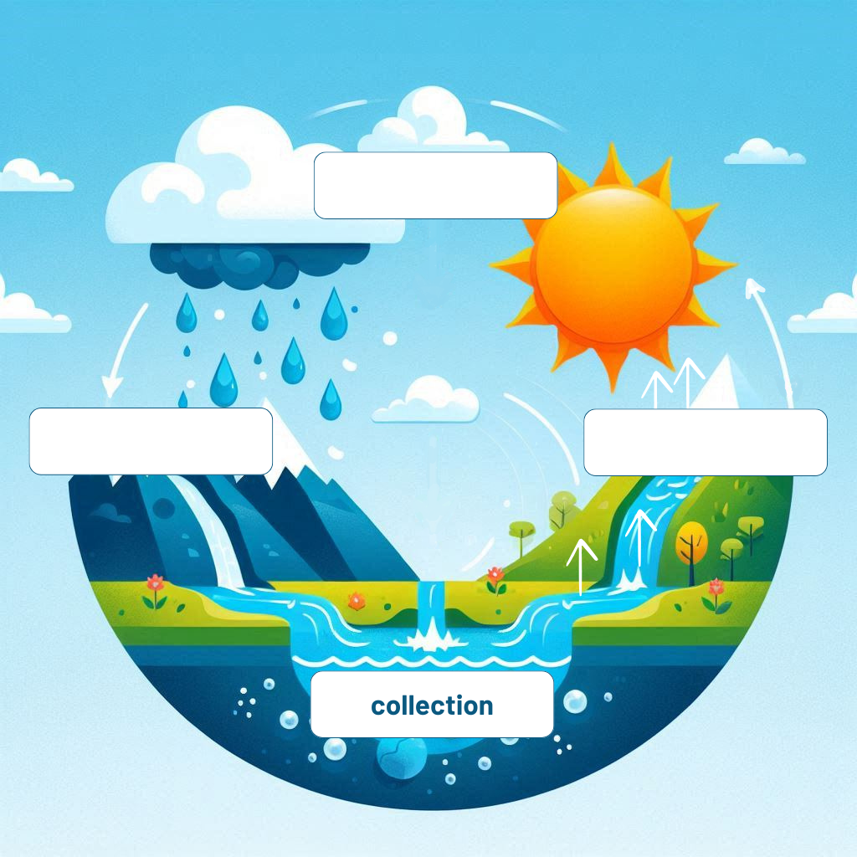
Or:
- Draw a simple picture that shows the water cycle.
Label the key stages:
- evaporation
- condensation
- precipitation

- Describe in your own words what happens at each key stage.
Evaporation:
_____________________________________________________________________________
_____________________________________________________________________________
_____________________________________________________________________________
Condensation:
_____________________________________________________________________________
_____________________________________________________________________________
_____________________________________________________________________________
Precipitation:
_____________________________________________________________________________
_____________________________________________________________________________
_____________________________________________________________________________

- What happens to the water in the container when it is placed near a sunny window?
_____________________________________________________________________________
_____________________________________________________________________________

- Why do we use red paint or food colouring in the water for this experiment?
_____________________________________________________________________________
_____________________________________________________________________________

- What role does the plastic film play in the experiment?
_____________________________________________________________________________
_____________________________________________________________________________

- What role does the stone play in the experiment?
_____________________________________________________________________________
_____________________________________________________________________________

- At the end of the experiment, is the water collected in the cup clear or red? Why?
_____________________________________________________________________________
_____________________________________________________________________________

- Write a short text and explain:
- Why is it important to understand the water cycle and how nature filters water?
- What can you do to help conserve water and protect the environment?
_____________________________________________________________________________
_____________________________________________________________________________
_____________________________________________________________________________
_____________________________________________________________________________
_____________________________________________________________________________
_____________________________________________________________________________

