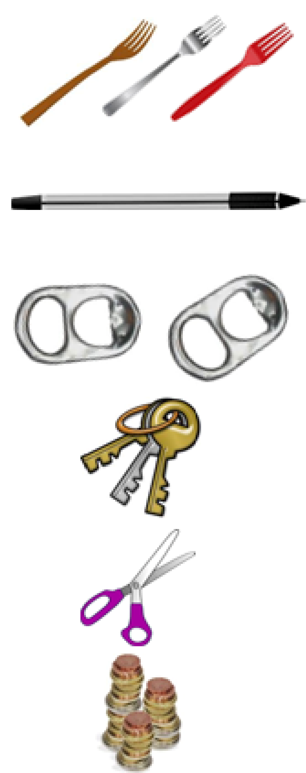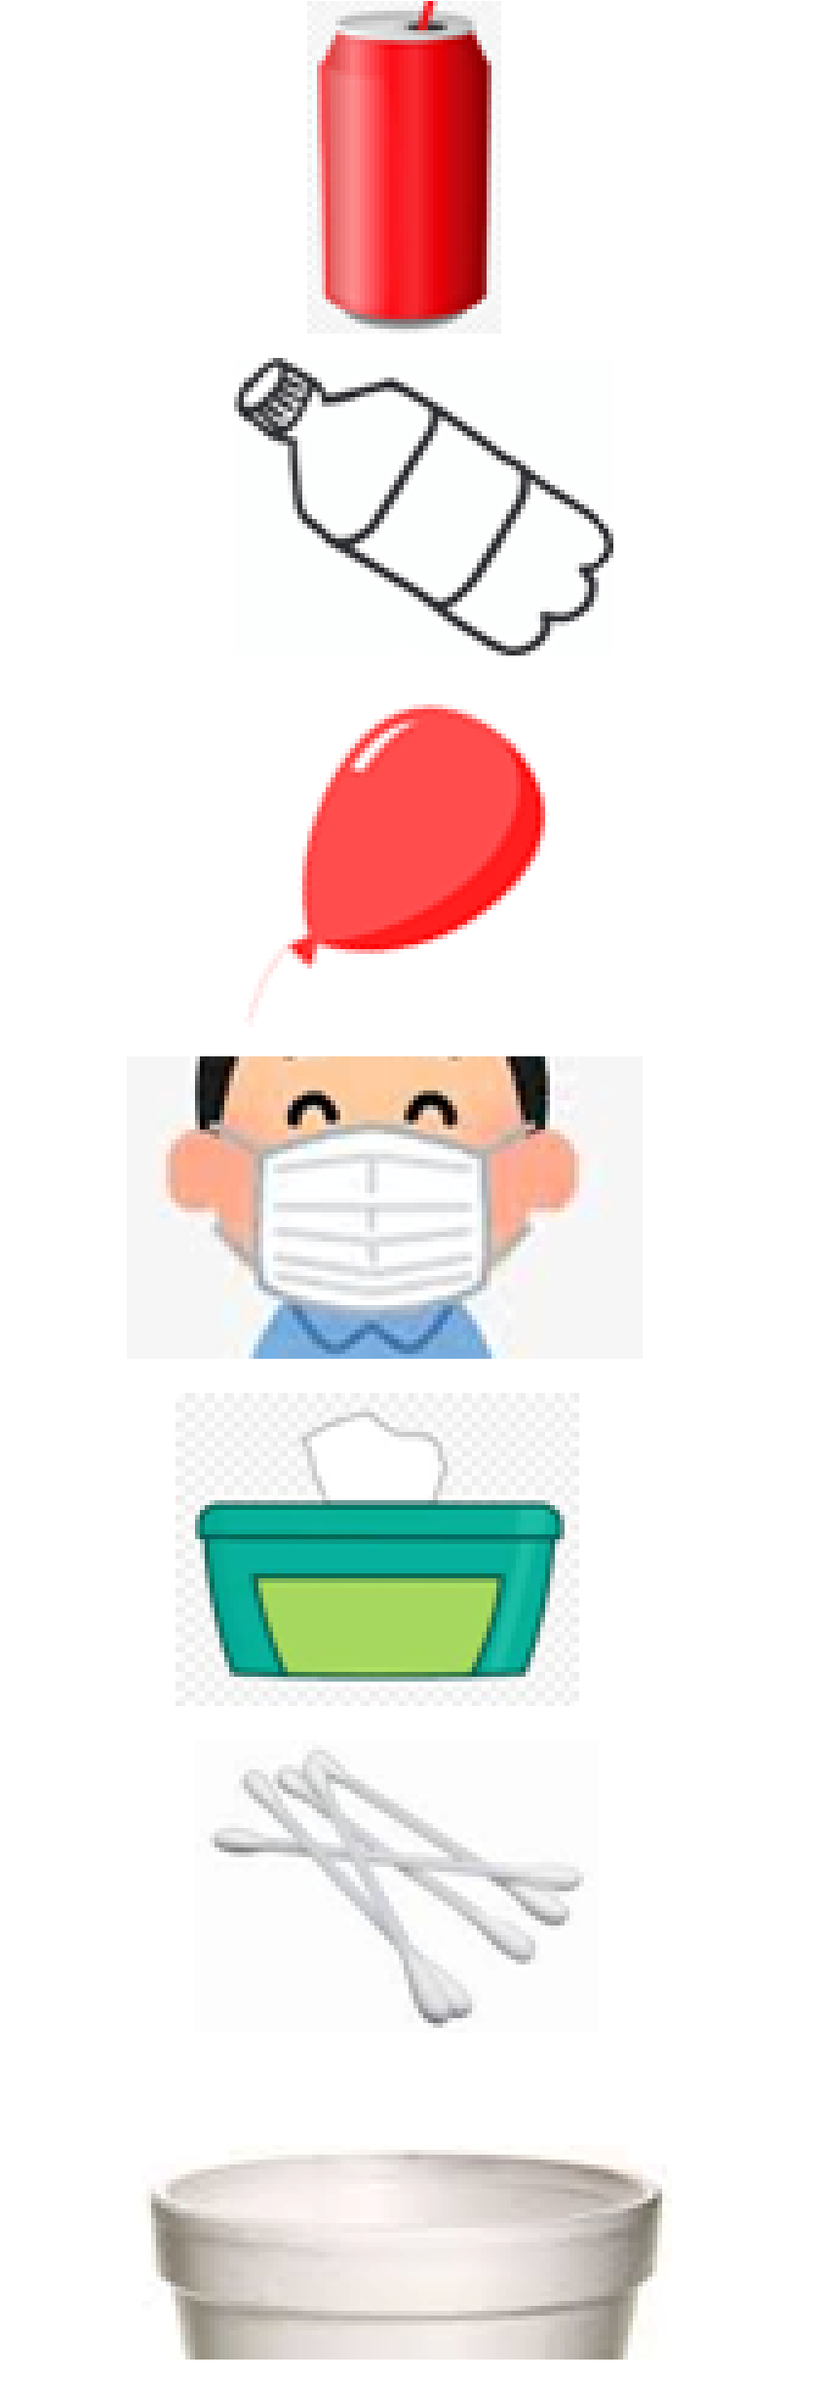

**wooden | metal | plastic**

**fork**

**pen**

**plastic bottle**

**drinks can**

**coins**

**scissors**

**keys**

**can tabs**

**polystyrene**

**cotton buds**

**wipes**

**mask**

**balloon**