States of matter

Answers for teachers

Complete the diagram with the names of the changes of states of matter.

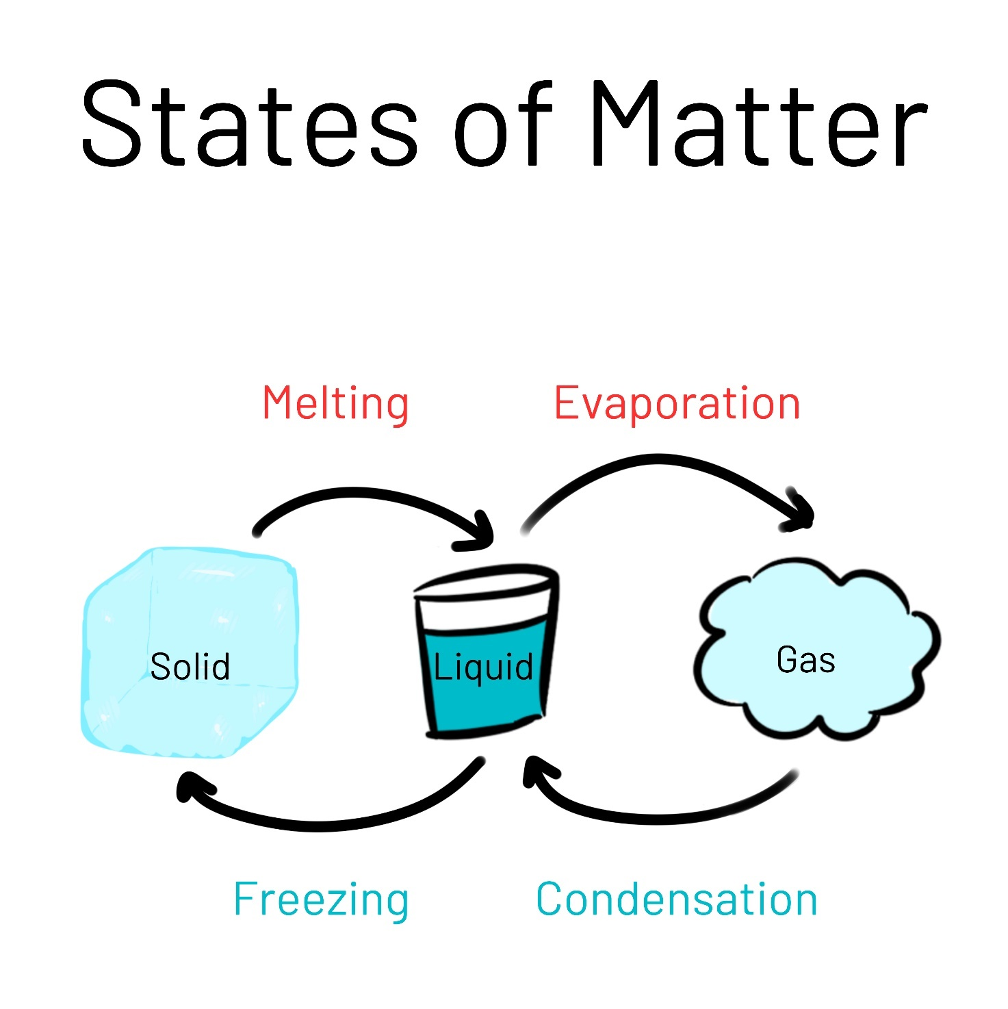

- Melting

- Evaporation

- Freezing

- Condensation

