States of matter

Complete the diagram with the names of the changes of states of matter.

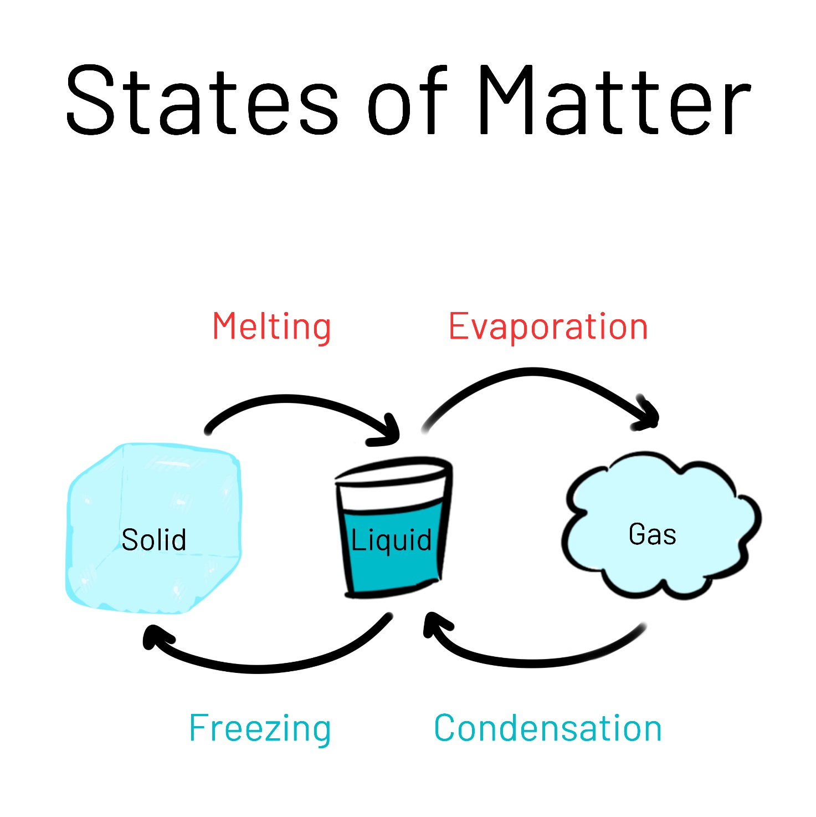

4

1

3

2

- ___________________________________________________________________

- ___________________________________________________________________

- ___________________________________________________________________

- ___________________________________________________________________

