Ein Bild, das Animierter Cartoon, Clipart, Animation, Darstellung enthält.
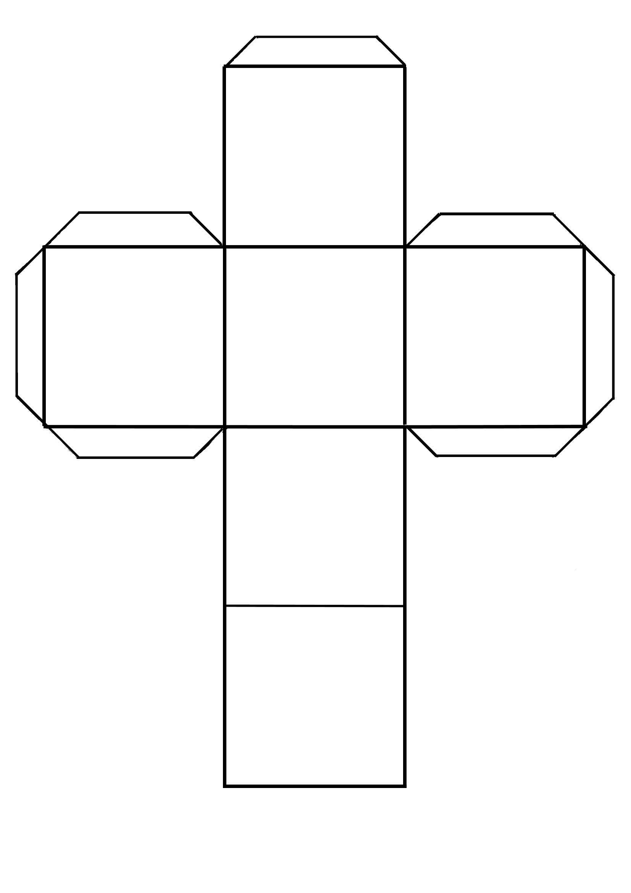

Taken from   
**Save our nature – Let’s explore together: Videos for primary**

A project by Science on Stage Germany

**Find a solution to prevent floods.**

**Find a solution to prevent ocean acidification.**

**Name a renewable energy source.**

**Name a problem caused by acid rain.**

**Name a problem caused by melting ice.**

**Name a cause of climate change.**