What is the secret to eco-friendly homes?
Exploratory guide

This guide will encourage children to think critically about the properties of the materials they are testing. The exploratory questions help develop scientific reasoning throughout the activity. The guide accompanies an experiment that is a very simplified model of reality, which can also be explored with children, helping them understand that these experiments are only models.

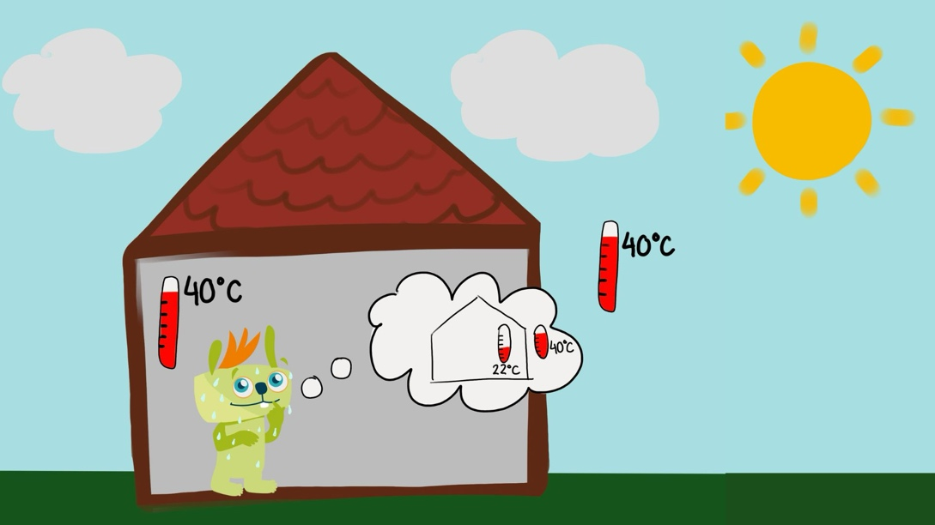

Objective

To explore with students why the temperature inside the house is nearly the same as outside and to find solutions to make the interior environment cooler. Moreover, it encourages students to ask many questions and explains that several factors influence the choice of materials for insulating a house.

1. Questions about the image

Start by showing the image to the students and asking:
“Does Lilu seem happy with the temperature inside the house?”
“Is it summer or winter?”
“What do you notice about the temperature inside and outside the house?”
“Why do you think the temperature inside the house is the same as outside?”

Identify the problem:
“Usually, should it be cooler or warmer inside a house compared to outside? Why?”
“Could there be something wrong with this house? What could it be?”

Materials of the house:
“What material do you think the walls of the house are made of?”
“What kind of materials or things do we know that can help prevent heat from entering the house?”

Exploring solutions:
“What could be done to make the house cooler inside, even when it is hot outside?”
“Have you ever heard of materials that help keep a house cool in summer and warm in winter? What might those materials be?”

2. Conducting the experiment

In this experiment, we will test different materials to compare their ability to insulate a house. Thermal insulators are materials that help prevent energy exchange between the inside and outside of a space, preventing the external temperature from influencing the inside. They are very important in our homes, helping keep us warm in winter and cool in summer.
In this experiment, we chose the summer season, so we will place our "houses" in the sun and see which material best prevents heat from entering and melting the ice.
We will use four different materials: air, denim fabric, straw, and wool. Each material has different characteristics that can influence how well they insulate against heat.

Why did we choose these materials?

Air - is a good insulator when trapped between layers of materials. That is why we have double-glazed windows and walls with air in between.
Straw - has been, and still is, used to build houses in various cultures around the world, so it must have good insulating properties.
Wool - is one of the most common materials used in warm clothing because it helps retain heat.
Denim - is a fabric we use in clothing and often discard after use, so if it proves to be a good insulating material, we can reuse old jeans and solve the problem of excess waste. Let us find out if it is good at keeping the heat out or if it lets the cold in.

Important

This activity raises some questions that can be explored early on. For example, the denim fabric we are using is dark blue, which means it may absorb more heat when exposed to the sun, potentially influencing the test results. How could we conduct an experiment to determine if color affects its insulating capacity? How about testing denim fabrics of different colors – some lighter, others darker?

