EcoArt with science

This EcoArt activity unites chemistry and art in a sustainable way. Together with your students, you can create one-of-a-kind pieces of fabric by dyeing them with natural dyes, such as red cabbage and turmeric. These two substances can be used as acid-base indicators, and by changing the pH values, we can create different colours.
Experiment with various methods and have fun exploring the endless possibilities of natural dyeing!

Required materials

- natural fabrics (cotton or linen)
- a red cabbage
- turmeric powder
- vinegar
- salt
- baking soda
- a pot
- wooden spoons or spatulas
- a filter
- gloves
- a cutting board
- a knife
- measuring jugs
- glass containers (for storing the dyes)
- water
- brushes and sponges (for painting)
- a cork or a potato (for stamps)
- a stove
- a cover to protect the work surface

The procedure

1. Wash the fabrics

2. Prepare the natural dyes
Red cabbage dye:
- Chop half of a red cabbage into small pieces.
- Place the pieces in a large pot and add enough water to cover them.
- Boil for about 30 minutes until the water takes an intense purple colour.
- Strain the mixture.
- Divide the mixture into three parts. Save one part, which will be the purple dye.
- To the second part, add baking soda until the mixture acquires the desired green colour.
- To the third part, add vinegar until it acquires a desired reddish-pink colour.
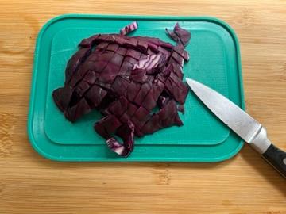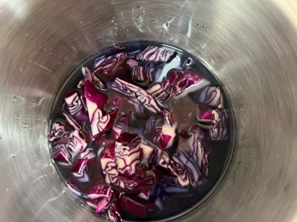
Turmeric dye:
- Put one tablespoon of turmeric powder and four cups of water into a pot.
- Boil the mixture for about 15 minutes.
- Strain the mixture to remove any turmeric powder and save the colouring liquid.
- Divide the mixture into two parts. Save one part, which will be the yellow dye.
- Add baking soda to the second part until it acquires a desired orange-reddish colour.

3. Dye the fabric
- Place the prepared fabric in the pot with the desired dye.
- Let the fabric rest in the dye for at least two hours.
- Remove the fabric from the dye and rinse it in cold water and salt until the water runs clear.
- Dry the fabric in the shade to prevent fading.
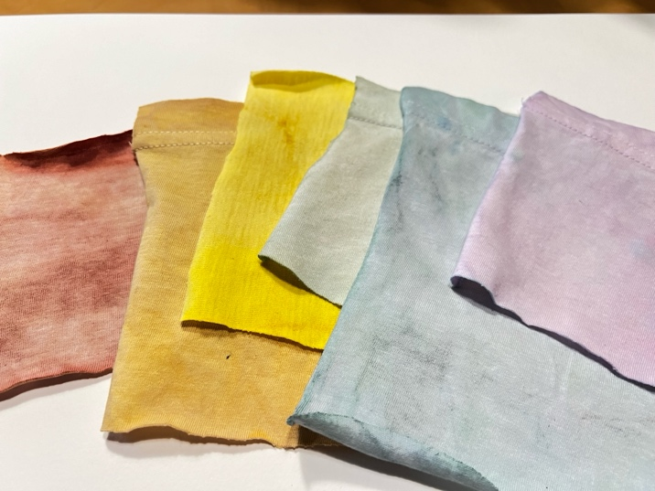
Sample pieces of fabric dyed with red cabbage and turmeric

4. Ideas for artistic dyeing
These natural dyes can be used to paint fabrics using a variety of techniques. Use paint brushes or sponges to create various textures. Make stencils or stamps from a cork or a piece of a potato.

