# The composting cycle

### 1. This cycle has a correct sequence, but which one of the pictures should be the first and why? Number the pictures in the cycle from 1 to 6.

### 2. Match the pictures with the numbers 1 to 6 with the correct description in the list below.

### 3. Which process does the cycle describe? Write it in the center of the image.

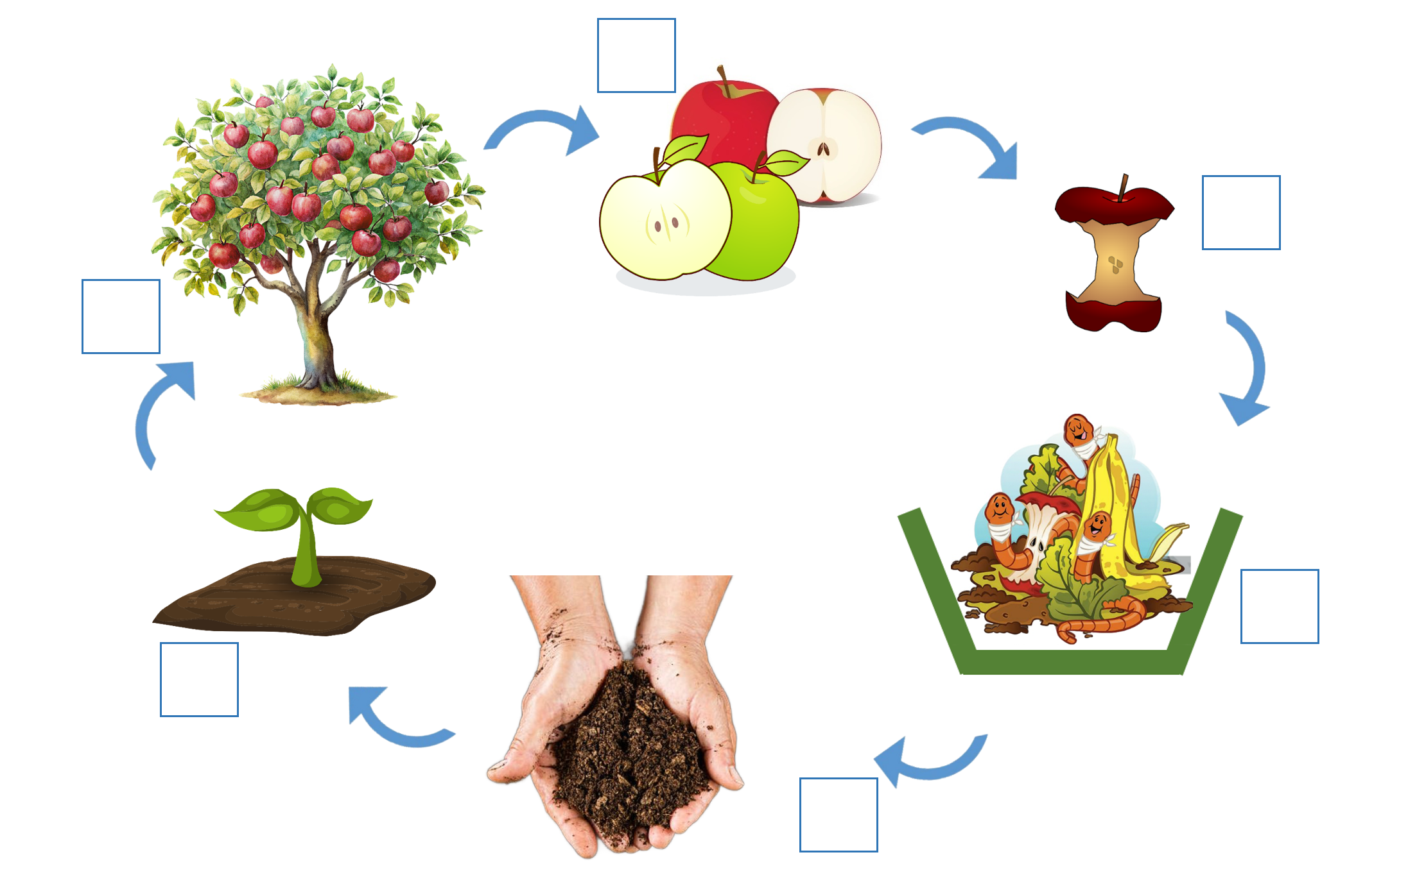

### Write the correct numbers in the boxes.

* soil with decomposed remains
* an apple tree
* an apple core
* a small plant growing from the soil
* a ripe apple
* worms and soil-working organisms