The composting cycle

Match the pictures with the numbers 1 to 6 with the correct description in the list below.

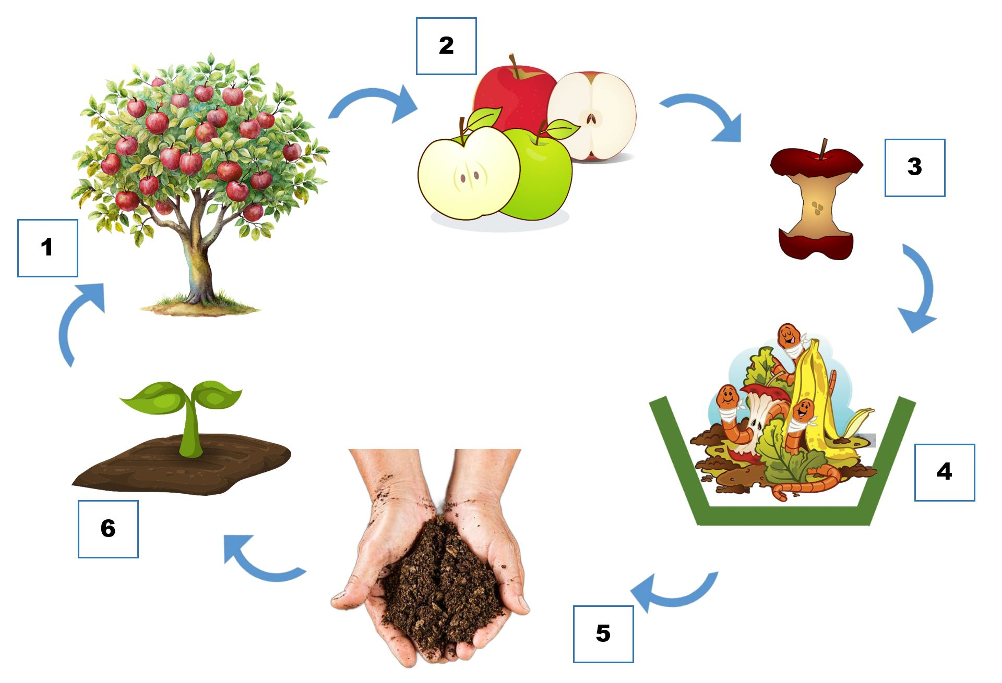

Write the correct numbers in the boxes.

- soil with decomposed remains

- an apple tree

- an apple core

- a small plant growing from the soil

- a ripe apple

- worms and soil-working organisms

